**Methods III -Final Project**

**Luiz Guilherme Roth Cantarelli**

**July/2019**

Does socialization under specific political environments increase preferences for income redistribution and social spending? I try to answer this question by analyzing two different transitions in Brazilian politics: Democratic transition (1989) and PT (Workers Party) first presidency (2003), by recurring to regression discontinuity models I try to find differences on young people that had already been through high school, by choosing having 20 years old at each period as a proxy to that. The outcome analyzed is preference regarding Bolsa Família spending and preferences toward higher taxes to rich people, both measured by questions on LAPOP (Latin America Public Opinion Project) Surveys.

**PT government:**

**Bolsa Família Preferences:** (1. Increase/Maintain 2. Decrease/Eliminate)

Regression discontinuity plot (Bolsa Família Preference x Age in 2003)



All data regression (socPT means having less than 20 years in 2003), the variable indicating socialization under PT is significant and on the expected direction:

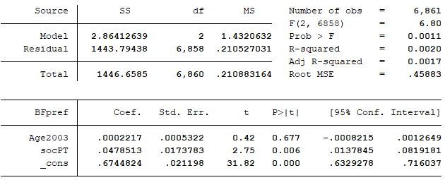

Regression discontinuity with a 2 years bandwidth, here there is also a significant result on the conventional method, but not in the robust one:

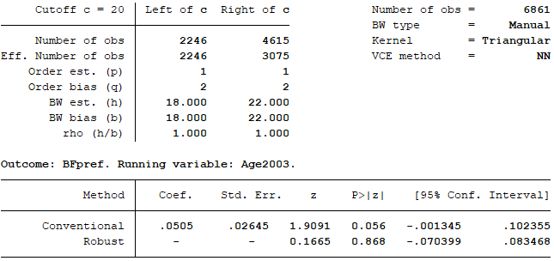

**Taxing the rich preferences:** (1. Rich should pay more taxes than poor / 0. Rich and poor should pay equal taxes)

Regression discontinuity plot – Quadratic:



All data regression. Also significant, here the socialization under PT has the opposite direction to what was expected:

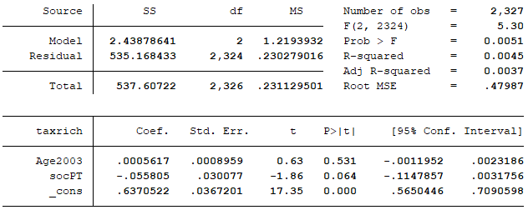

Regression discontinuity with optimal Bandwith. No significance on the discontinuity model:

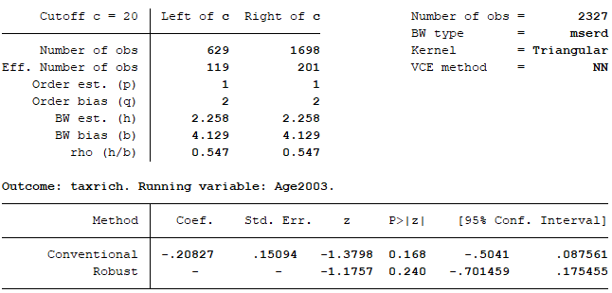

**Redemocratization 1989:**

**Bolsa Família Preferences:**

Regression discontinuity – quadratic:



All data regression (socDEM equals having 20 years in 1989), the underlying variable is significant on the expected direction, but the threshold dummy is not:

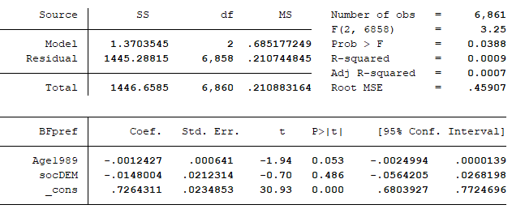

Regression discontinuity with 2 years bandwidth. Significant on conventional model, but with opposite signal:

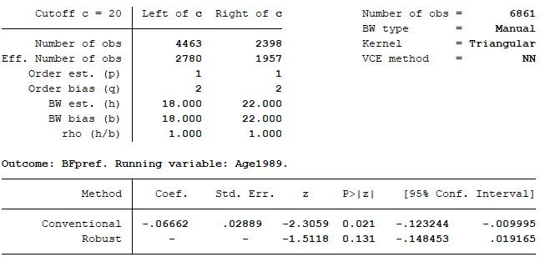

**Taxing the rich preferences:**

Regression discontinuity plot



All data regression. Threshold not significant, again the underlying variable is significant.

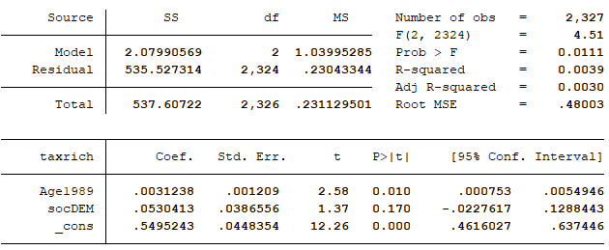

Regression discontinuity optimal bandwidth. No significant results: